Anthony G. Ambrosio

517 Centennial Drive

Cullowhee NC, 28723

334-446-8973

[Matthewb294@yahoo.com](mailto:Matthewb294@yahoo.com)

September 27, 2018

Ms. Myers

Chief of Human Resources Officer

Hyatt Corporation

150 North Riverside Plaza, 8th Floor

Chicago, IL 60606

Dear Ms. Myers:

This letter is to express my dissatisfaction about the services I acquired from the Hotel Manager, Bill Wilson, of the Charlotte, NC Hyatt House hotel complex. I called on the 4th of November to mend the problem of having my credit card charged $150 for that aforementioned date. I received the charge, despite my on-time checkout of 11:15 o’clock on the 3rd of November.

When I called the Hyatt House located within Charlotte, NC, to inquire about the charge, the desk clerk proceeded to get the Hotel Manager, Bill Wilson. When faced with the problem, the first steps he took was not to investigate further but to quote Hyatt House company policy. I personally felt this action to be condescending behavior and that he did not take my problem as serious as he could. I had stated my problem of being charged an extra day three times to Bill Wilson before he asked for confirmation of my identity. From there he stated he did find the records of my stay which stated I checked out the 4th of November. I explained multiple reasons why that was not possible and asked if he could double check with the desk clerk that signed me out. Bill Wilson blatantly refused to get into contact with the desk clerk who checked me out of my room on the 3rd of November. I asked if he could check security cameras that would have recorded my exit but Bill Wilson also refused this suggestion. Instead of making any suggestions to alleviate my problem, Bill Wilson proceeded to ask “is that all for today?” Asking this made me feel like he was forcing the conversation to a close.

I was hoping to achieve a more satisfactory outcome to my problem from the Hyatt Organization. This ordeal has left me with feelings of stress alongside disappointment due to the financial loss and lack of help from Bill Wilson. At the least, I hope to be paid back the full amount I was charged on the extra day I was not there. I will keep this experience in mind when visiting Charlotte, and when advising friends for trips to Charlotte, North Carolina.

Sincerely, Matthew Beaver

Ms. Hailey Moon  
Books Galore  
567 Technology Drive  
Albuquerque, Nm 87110

October 15, 2017

Ms. Ann Brand  
1234 Bright View way  
Cullowhee, NC 28723

Dear Ms. Brand

I am truly appalled about the first ordering mistake, and became further distressed upon the topic of two more ordering mistakes as mentioned in your letter of October 15, 2017.

We at Books Galore consider customers to be our main concern, and it saddens us to hear of such mistakes. From the information gathered from your previous letter you are requesting a copy of *Herb Garden Designs* within one week and a shipping reimbursement of $15,90. However, it personally hurts me to inform you due to company policy, and subscriber agreements we can only partially fulfill your request.

We at Books Galore do our best to match the correct packages with customers through a tech based team. To double check our packaging info our delivery drivers are required to have documentation to match info on packaging with info on customer packages. These documents the delivery drivers have you sign upon their arrival states company policy that states all financial transactions have been finalized and cannot be altered with the signing of the documents. Thus, we can still re-send a copy of the, *Herb Garden Design,* but cannot reimburse you for the $15.90 requested. However, We at Books Galore will reassess digital documentation of all subscribers, retrain delivery drivers on checking packages with documentation, and re-format subscriber documents alongside info on packages as to enhance readability for both ,delivery drivers and customers, on personal info as to make sure it is the correct package.

We truly regret the grievances caused by the past three delivery mistakes and hope you give us one more chance to prove we can be a reliable source of literature for valued subscribers such as yourself.

Sincerely,  
Ms. Hailey Moon  
Books Galore

Matthew Beaver

572 Centennial Drive | 334-446-8973 | matthewb294@yahoo.com

10/02/2018

Anthony G. Ambrosio

Senior Executive Vice President, Chief Administrative Officer and Chief Human Resources Officer of the Columbian Broadcasting System

51 W. 52nd Street

New York, NY 10019

**Dear Mr.Ambrosio**

I am applying for an internship for the 2018 Smithsonian Channel Fall Internship-Production (Washington, DC). I already have arrangements made for my own residency within the city of Washington DC if I acquire this internship. While at this internship, I hope to gain firsthand experience in the field of video production as well as continue my passion for video production.

I am currently enrolled in Western Carolina Universe, where I ‘am currently pursuing a major in Film and Television Production. I would like to assist with making awe-inspiring stories with the 2018 Smithsonian Channel Fall Internship-Production (Washington, DC). I have experience in my college level courses with video equipment such as: DSLR camera’s, camera phones, Zoom audio recorders, and many other recording devices. I have acquired experience with video and photo programs such as: Adobe Pro Premiere, and Photoshop. Other college courses I have taken in English have supplied me with extensive experience with; Microsoft word, Power Point, and Excel. I have been a part of and supported a team cohesively within all the jobs I have held, and have fulfilled multiple tasks required in college level courses under a fast-paced environment, while under deadlines.

I currently have taken college courses within Psychology, Sociology and Art History which I believe can contribute in many ways in the production of videos. One personal project I have recently completed is my own personal 255 paged screenplay; based on a movie outline I wrote myself.

I thank you all at the Columbian Broadcasting System and the Smithsonian Channel for considering me for this possible internship. I hope to hear back from you at the Columbian Broadcasting System for an interview with my resume attached. You can contact me by my phone number: 334-446-8973, and professional email at: matthewb294@yahoo.com

Sincerely, Matthew Beaver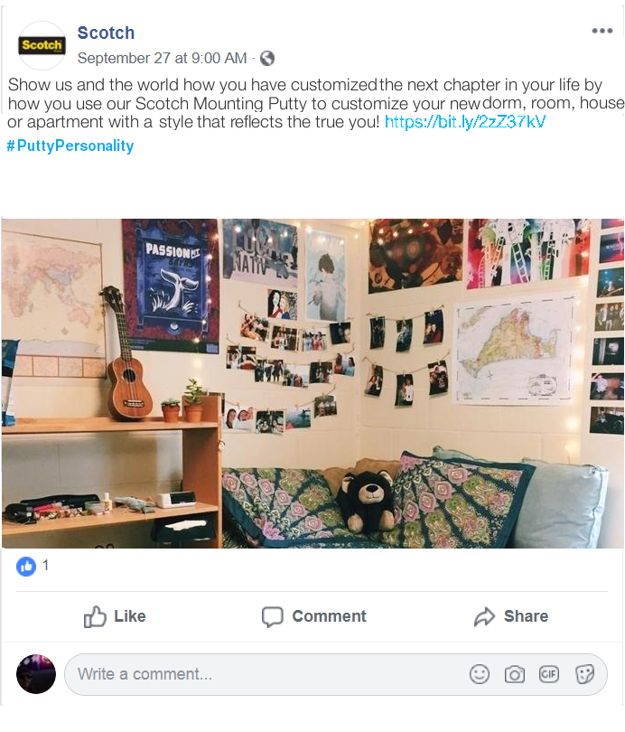

Matthew Beaver

Blog Updated: 10/8/2018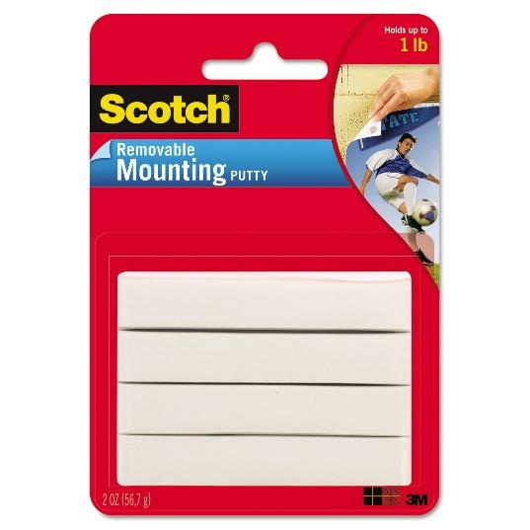

***Making your Home, Homey rather than Holey.***

Home is where the heart is, home is also who we are and we want our homes to reflect that. We want our homes to reflect who we are on almost every surface. That is why we don’t want to damage those surfaces but we still want to make the most of them. The go-to tool for mounting things on a wall is a hammer and nail. However, a hammer and nail can be a time consuming, overly damaging, and loud process that causes unneeded stress to a person’s warm household. The natural alternative to hammer and nails would be adhesive tape to hold things on our homes walls. However, tape does come with frustrating drawbacks like less strength for holding weight up, leftover adhesive on the walls when peeled off, and an unseemly amount possibly required to hold beautiful home décor. That is why I would recommend Scotch Mounting Putty which eases the burden of having to repair or clean the walls when mounting your personal home décor. Scotch Mounting Putty is a cheap, effective, clean, strong alternative to the usual mounting utensils for decorating your home. All you have to do is tear off a piece of Scotch Mounting Putty, roll it in your creative hands, stick the putty to the back of what you want mounted on the wall and firmly press it to the surface of choice. Please keep note however that various amounts of Scotch Mounting Putty might be necessary for heavier more intricate home décor items or projects. Scotch Mounting Putty unlike nails that become unusable due to being bent upon removal or tape that loses their adhesive after one use, mounting putty can be saved and re-rolled later for future projects. Scotch Mounting Putty can be used for various projects and reasons within a household; a family wall of framed photos, a teenager’s poster covered room, use it to keep flat surface décor in place or any other family oriented home projects. The Target website currently has 103 reviews on Scotch Mounting putty with an average 4-star rating. Read these personal thoughts on Scotch Mounting Putty on the Target website; Snowberry9 states “This putty works well when adhesive strips are not allowed because they damage the walls. This putty does no damage and is great for sticking up laminated posters and pictures. I'm on my second package” and Garden Maiden quotes about Scotch Mounting Putty I spent 6 months testing this product. I hung led light switches upside down outside, wall mounted indoors. The Indoors ones are still firmly in place. Straightened pictures, hung indoor antennas, temporarily held nails, screws, and hardware during installs, hold the dog door open for foster dogs (weeks on end) mount cellphone to the car. Love this mounting putty take it everywhere. Wash to revive and reuse.” Hoping to keep your home intact with no holes and avoid sticky adhesive covered walls while still personalizing your home to reflect you and your warm family, then give Scotch Mounting Putty a try.

